*Dados 2v2 - Virtue*

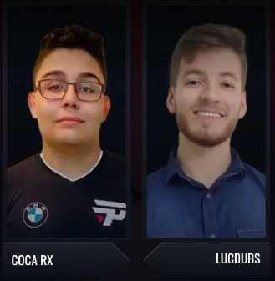

Caio Moreira

| **DECKS USADOS NA CBCR:**  **(DECKS USED AT CBCR)** |
| --- |

|  |  |  |  |
| --- | --- | --- | --- |
| 3W -0L  100% WR | 1W - 0L  100% WR | 1W - 0L  100% WR | 1W - 0L  100% WR |
|  |  |  |  |

| **DECKS USADOS POR ADVERSÁRIOS:**  **(DECKS USED BY ADVERSARIES)** |
| --- |

|  |  |  |  |
| --- | --- | --- | --- |
|  |  |  |  |
|  |  |  |  |

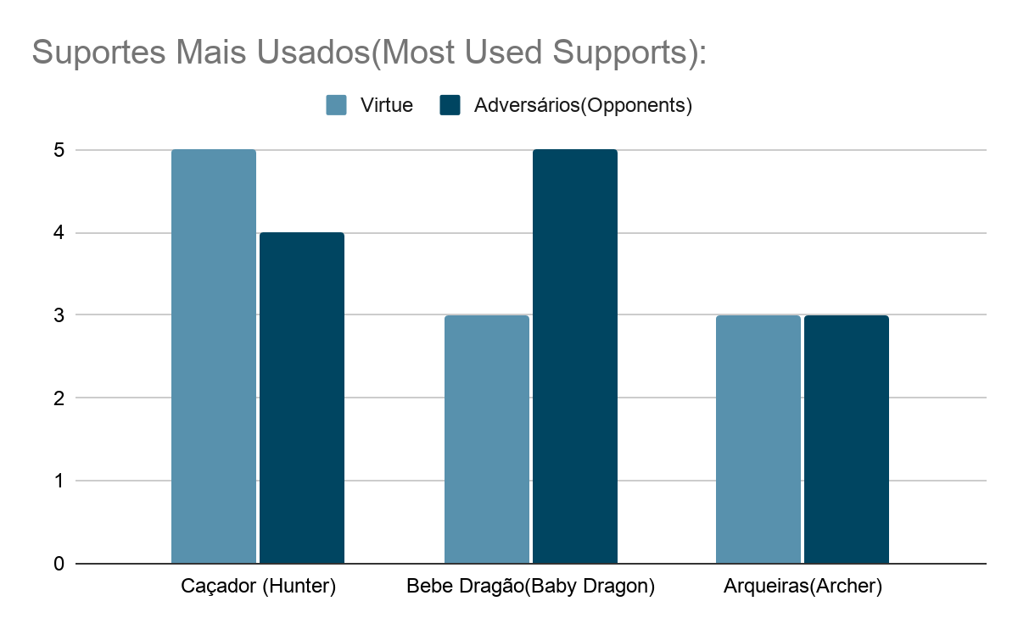

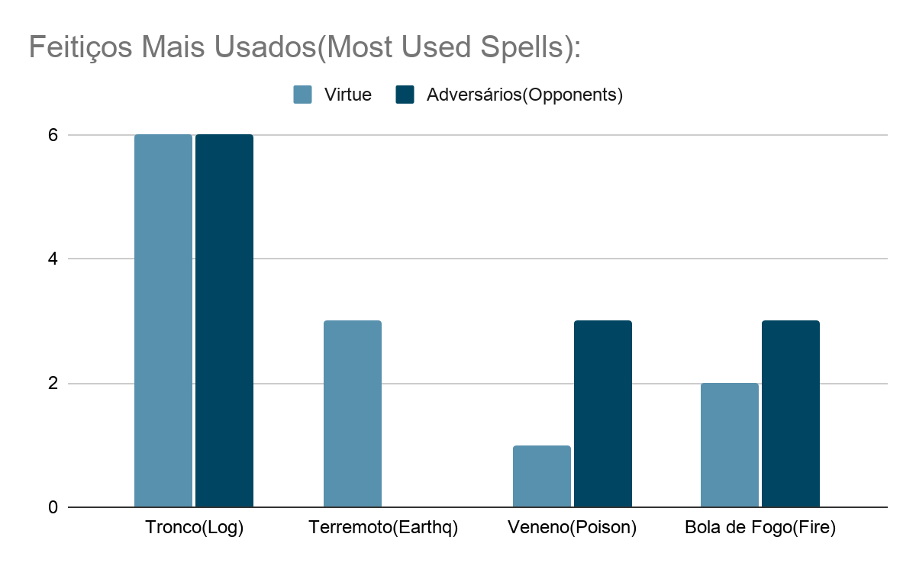

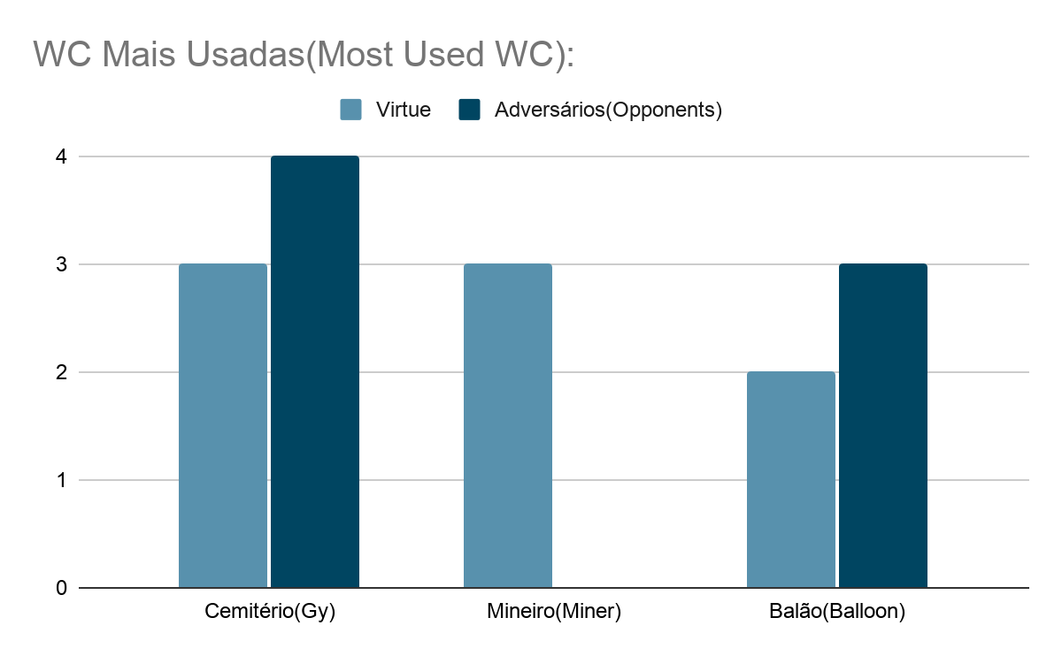

| **BANS DADOS POR ADVERSÁRIOS:**  **(BANS GIVEN BY ADVERSARIES)** |
| --- |

|  |  |  |
| --- | --- | --- |
|  |  |  |

| **BANS VIRTUE:**  **(VIRTUE DATA BANS)** |
| --- |

|  |  |  |
| --- | --- | --- |
|  |  |  |